**Ubuntu basics and DHCP setup**

**Create a folder:** mkdir ~/proba ~/archiv ~/proba/masolando

**Create a file** touch ~/proba/masolando/minta1.txt

cp ~/proba/masolando/minta1.txt ~/archiv/

mv ~/proba/masolando/minta1.txt ~/proba/masolando/mintafajl.txt

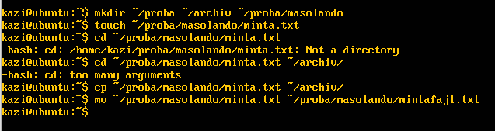

sudo groupadd vendeg

sudo groupadd helyi

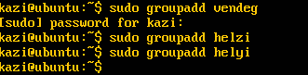

sudo useradd -m -g helyi -G vendeg -p $(openssl passwd -6 acbx) minta1

**Ownership transfer**

sudo chown minta1 ~/proba/masolando/mintafajl.txt

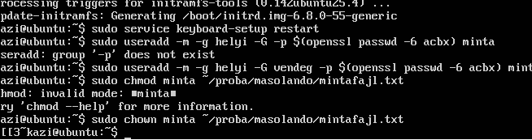

chmod 754 ~/proba/masolando/mintafajl.txt

sudo chown :vendeg ~/archiv

sudo chmod 770 ~/archiv

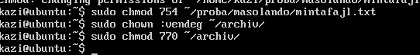

**Mysql Installation**   
sudo apt update

sudo apt install mysql-server

**Commands:**

mysql_secure_installation

sudo mysql -u root -p

**MYSQL Query:**

CREATE USER 'user'@'%' IDENTIFIED BY '12345';

GRANT ALL PRIVILEGES ON *.* TO 'user'@'%' WITH GRANT OPTION;

FLUSH PRIVILEGES;

**DHCP**

sudo apt update

sudo apt install isc-dhcp-server

**Adding config to /etc/dhcp/dhcpd.conf file:**

subnet 10.0.0.0 netmask 255.255.255.0 {

range 10.0.0.100 10.0.0.200;

option routers 10.0.0.1;

option domain-name-servers 10.0.0.10;

}

